PROJECT DEVELOPMENT PHASE

DELIVERY OF SPRINT-3

|  |  |
| --- | --- |
| Date | 12 November 2022 |
| Team Id | PNT2022TMID15007 |
| Project Name | Hazardous area monitoring for  industrial power plants using IOT. |

# SPRINT 3: MIT Application Inventor

* Building an application for our project using MIT application, designing the model and testing the application.

# STEP 1: Connecting required nodes in the Node-red platform.

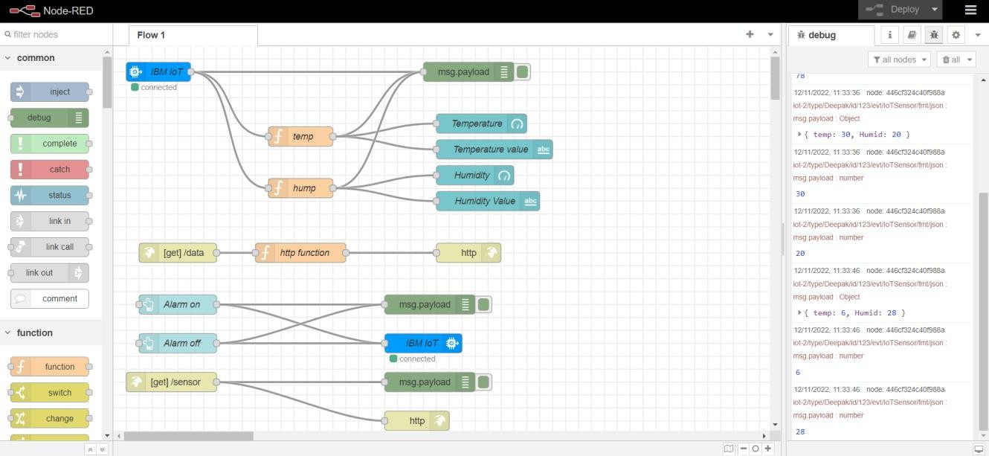

Display link: [h t t p s : / / n o d e - r e d - c g x s y - 2022 - 10 - 0 6 . e u -](https://node-red-cgxsy-2022-10-06.eu-gb.mybluemix.net/ui/%23!/0?socketid=RN5KWx_3DExG8KE1AAAN)

[g b . m y b l u e m i x . n e t / u i / # ! / 0 ? s o c k e t i d = R N 5 K W x _ 3 D E x G 8 K E 1 A A A N](https://node-red-cgxsy-2022-10-06.eu-gb.mybluemix.net/ui/%23!/0?socketid=RN5KWx_3DExG8KE1AAAN)

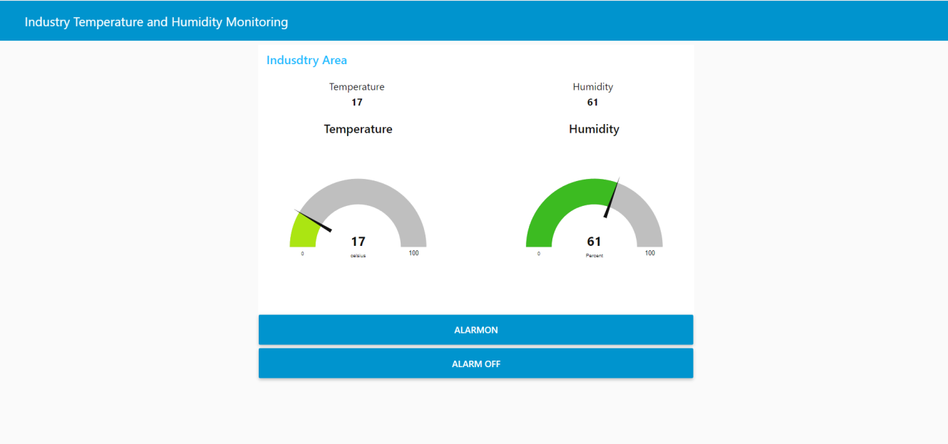

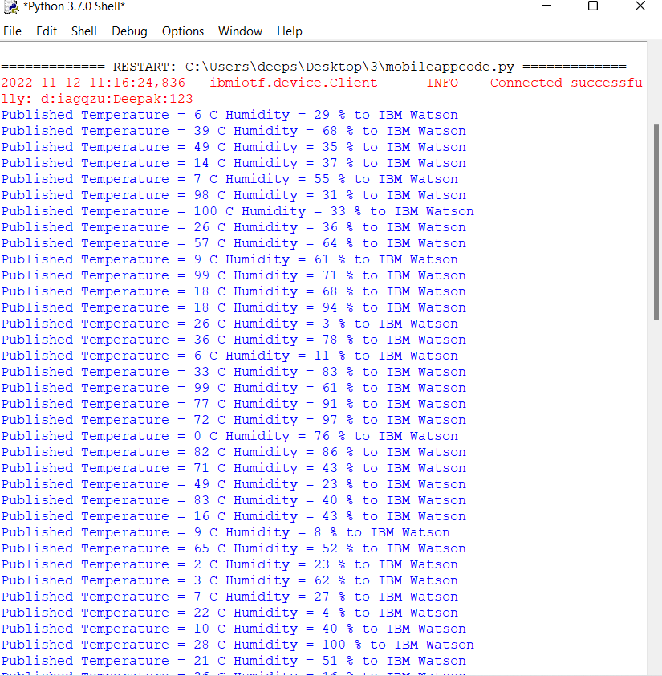

STEP 2: Displaying Alarm condition [https://node-red-cgxsy-2022-10-06.eu-](https://node-red-cgxsy-2022-10-06.eu-gb.mybluemix.net/control?command=AlarmOn) [gb.mybluemix.net/control?command=AlarmOn](https://node-red-cgxsy-2022-10-06.eu-gb.mybluemix.net/control?command=AlarmOn)

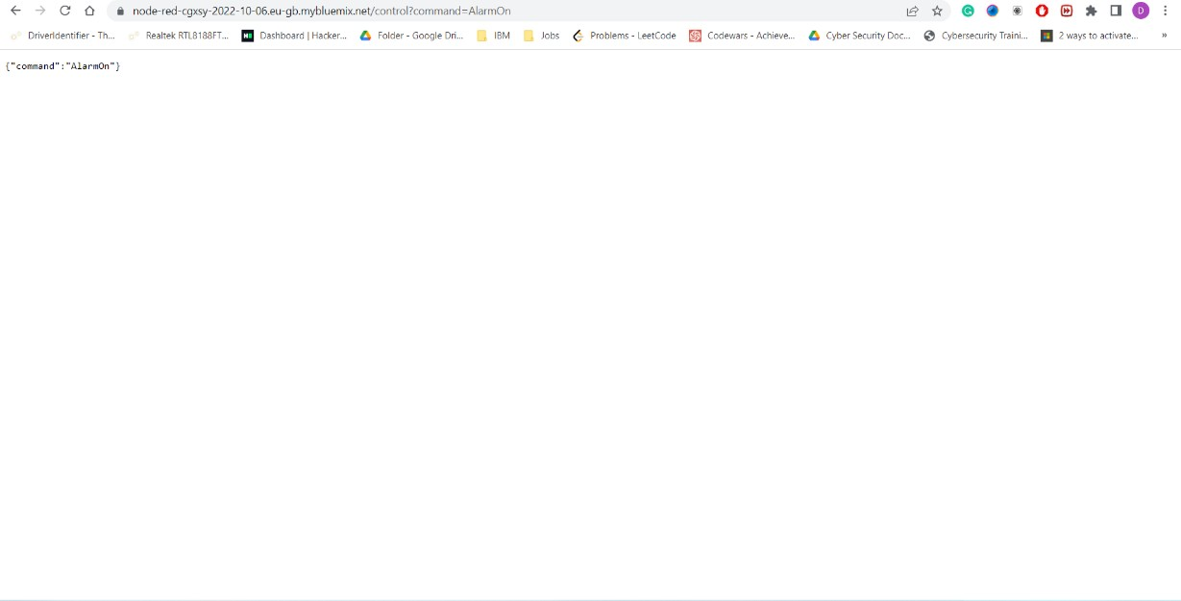

STEP 3: Connecting with the MIT Application Inventor to display temperature, humidity and alarm condition.

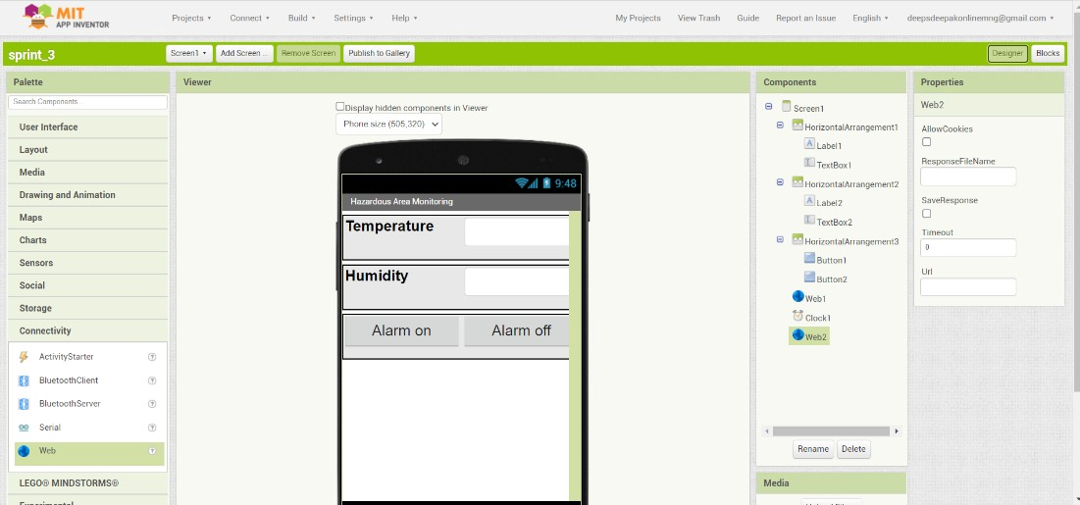

STEP-4: Attaching web link with the connected blocks in the MIT application inventor

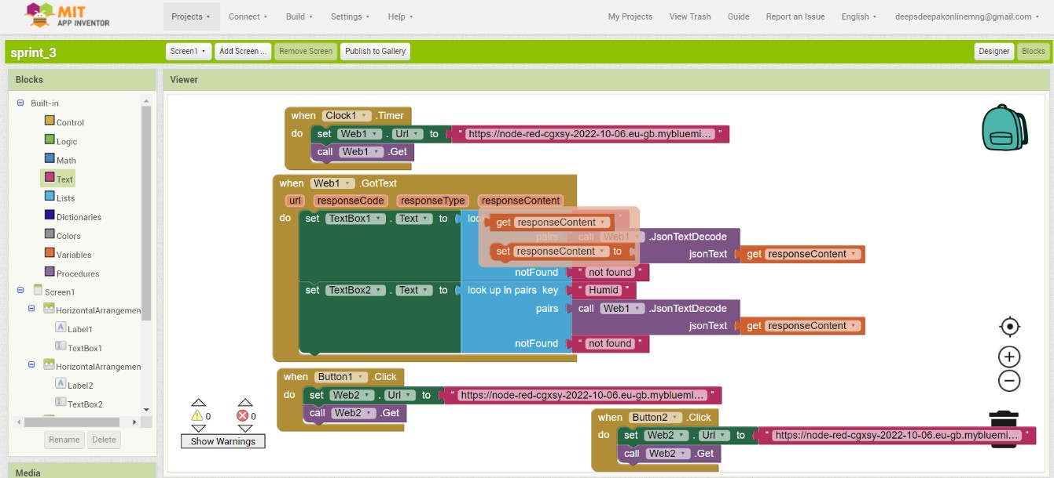

STEP-5: Detecting high temperature and displaying “ALERT” message in the MIT application.

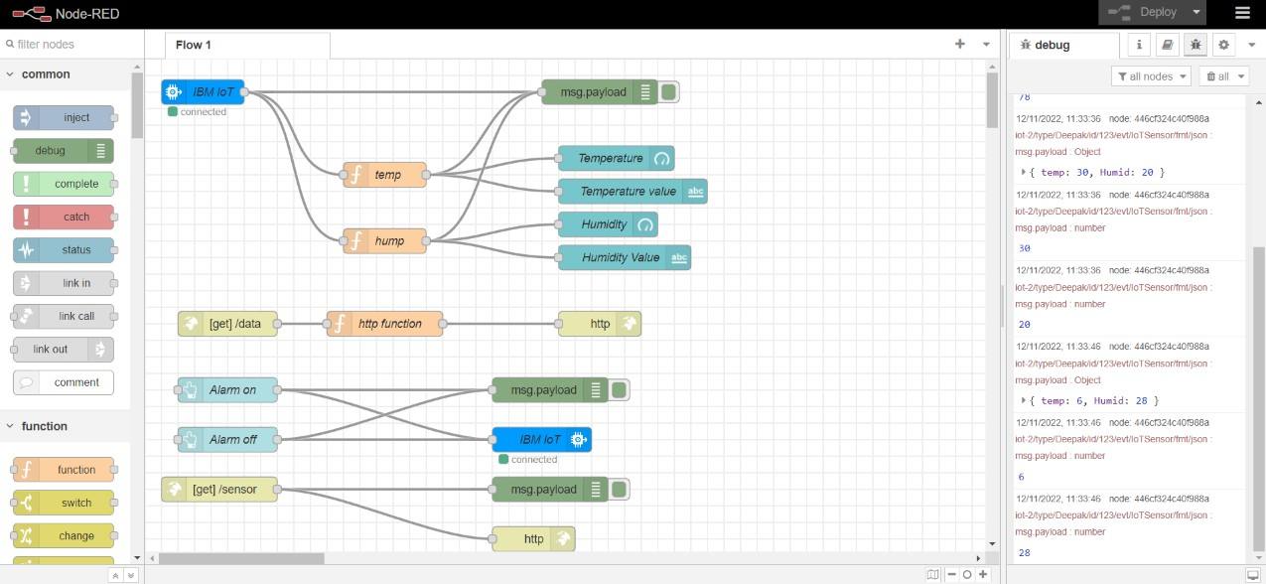

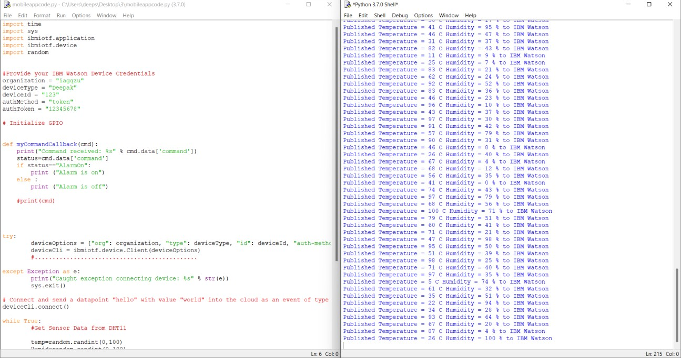

STEP 6: Downloading apk file and building mobile application using python script for sensing temperature for hazardous area monitoring conditions in industrial areas.

